Frequency Comparisons:

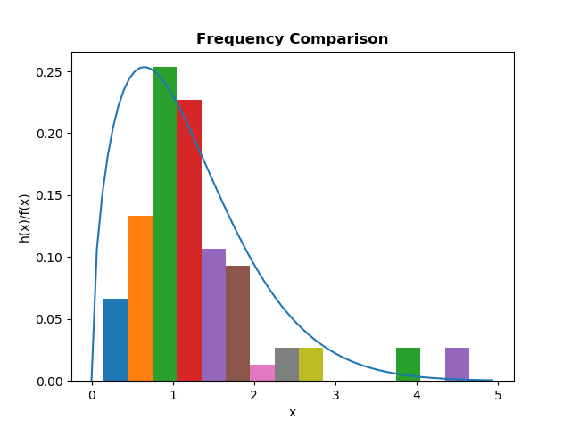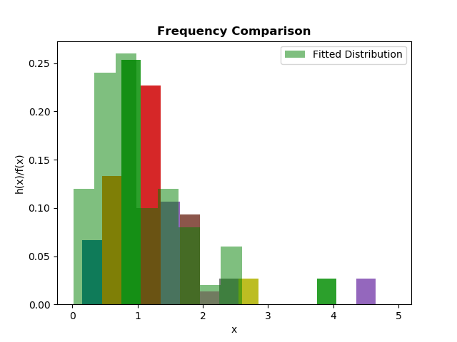

For Frequency Comparison, the fitted distribution is not a good representation of the true

underlying distribution of the data because sample size(=75) is not sufficiently large, on the other hand fitted distribution is generated for sufficiently huge data.

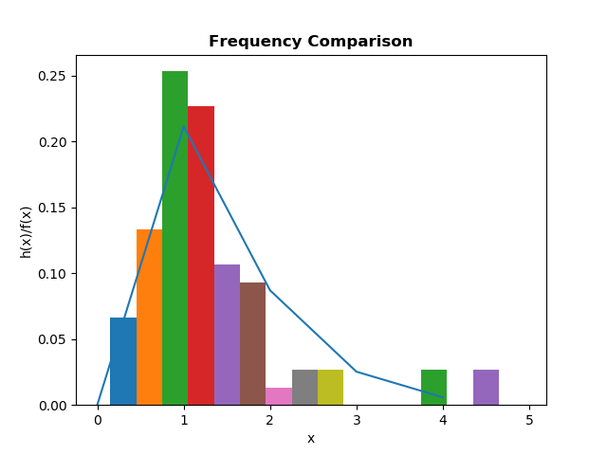

But if we take the fitted distribution for small size of data we can see it almost follows the underlying distribution. So we can say, Frequency Comparisons almost represents the underlying distribution.

Distribution –Function –Difference:

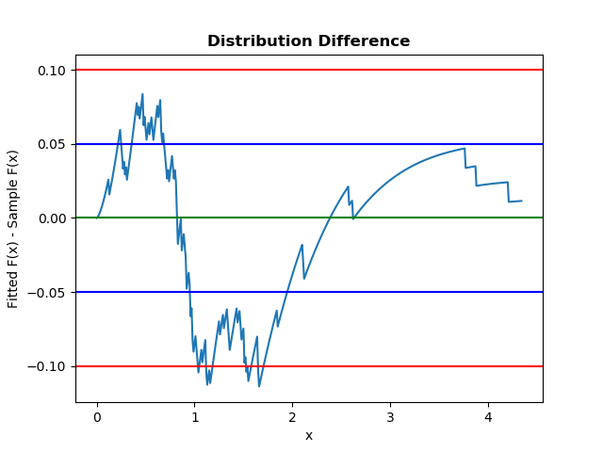

We can see the difference plot crosses blue and red lines in several cases. It does remain stable near 0.0. So we can say it is not good fitted in this fitted model due to small sample size(=75). However if sample size were large enough we would expect a good fit.

P-P Plot:

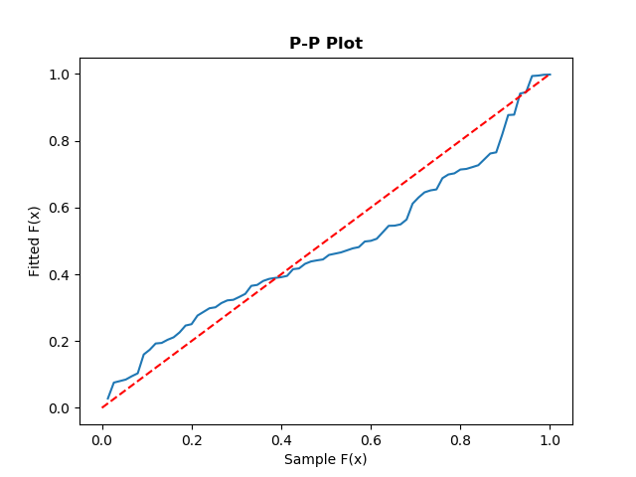

Here, Sample distribution almost follows Fitted distribution with some deviation in some places due to small dataset(=75). So, we can say this fitted model is a good representation of the sample distribution.

Q-Q Plot:

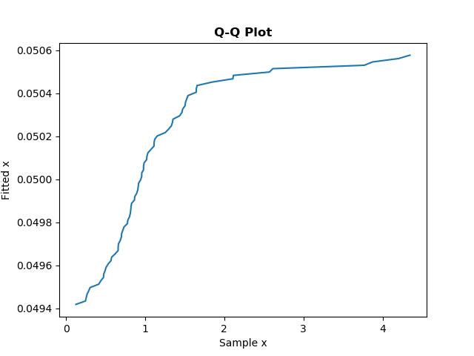

Here, Sample distribution almost follows Fitted distribution with some deviation in the middle due to small dataset(=75). So, we can say this fitted model is a good representation of the sample distribution.

Chi-Square Test:

We choose No. of Intervals k=15.

So n*Pj= 75*(1/15)

= 5

So the conditions of equiprobable intervals k>=3 and n*Pj>=5 for all j is satisfied.

Simulation Result:

j: 1 Interval= [0.000000, 0.225907) nPj= 5.000000 Nj= 1 ((Nj-nPj)^2)/nPj= 3.200000

j: 2 Interval= [0.225907, 0.364165) nPj= 5.000000 Nj= 5 ((Nj-nPj)^2)/nPj= 0.000000

j: 3 Interval= [0.364165, 0.487054) nPj= 5.000000 Nj= 4 ((Nj-nPj)^2)/nPj= 0.200000

j: 4 Interval= [0.487054, 0.604179) nPj= 5.000000 Nj= 5 ((Nj-nPj)^2)/nPj= 0.000000

j: 5 Interval= [0.604179, 0.720000) nPj= 5.000000 Nj= 8 ((Nj-nPj)^2)/nPj= 1.800000

j: 6 Interval= [0.720000, 0.837511) nPj= 5.000000 Nj= 8 ((Nj-nPj)^2)/nPj= 1.800000

j: 7 Interval= [0.837511, 0.959324) nPj= 5.000000 Nj= 9 ((Nj-nPj)^2)/nPj= 3.200000

j: 8 Interval= [0.959324, 1.088220) nPj= 5.000000 Nj= 7 ((Nj-nPj)^2)/nPj= 0.800000

j: 9 Interval= [1.088220, 1.227652) nPj= 5.000000 Nj= 4 ((Nj-nPj)^2)/nPj= 0.200000

j: 10 Interval= [1.227652, 1.382473) nPj= 5.000000 Nj= 5 ((Nj-nPj)^2)/nPj= 0.000000

j: 11 Interval= [1.382473, 1.560331) nPj= 5.000000 Nj= 7 ((Nj-nPj)^2)/nPj= 0.800000

j: 12 Interval= [1.560331, 1.774970) nPj= 5.000000 Nj= 3 ((Nj-nPj)^2)/nPj= 0.800000

j: 13 Interval= [1.774970, 2.056158) nPj= 5.000000 Nj= 1 ((Nj-nPj)^2)/nPj= 3.200000

j: 14 Interval= [2.056158, 2.495141) nPj= 5.000000 Nj= 2 ((Nj-nPj)^2)/nPj= 1.800000

j: 15 Interval= [2.495141, 4.445000) nPj= 5.000000 Nj= 6 ((Nj-nPj)^2)/nPj= 0.200000

No. of Intervals k: 15

X2: 18.0

X2(15-1,1-0.05): 23.685

X2(15-1,1-0.10): 21.064

Cannot Reject the Hypothesis at alpha=0.05

Cannot Reject the Hypothesis at alpha=0.10

**So, Chi-Square Test gives us no reason to conclude that our sample data is poorly fitted by Weibull(alpha=1.5278996202501096,beta=1.2999425079066453)distribution.**